

by

Yadwinder Pal Singh, 7519481

**References**

**Images**

[**https://www.pexels.com/**](https://www.pexels.com/)

[**http://myntra.com/**](http://myntra.com/)

**Responsive design**

[**http://getbootstrap.com/**](http://getbootstrap.com/)

**Php Installation on Mac**

I have installed **MAMP.** It starts Apache and MySQL server by starting servers. All projects need to be placed at this location:

**Finder > Applications > MAMP > htdocs**

**Login**

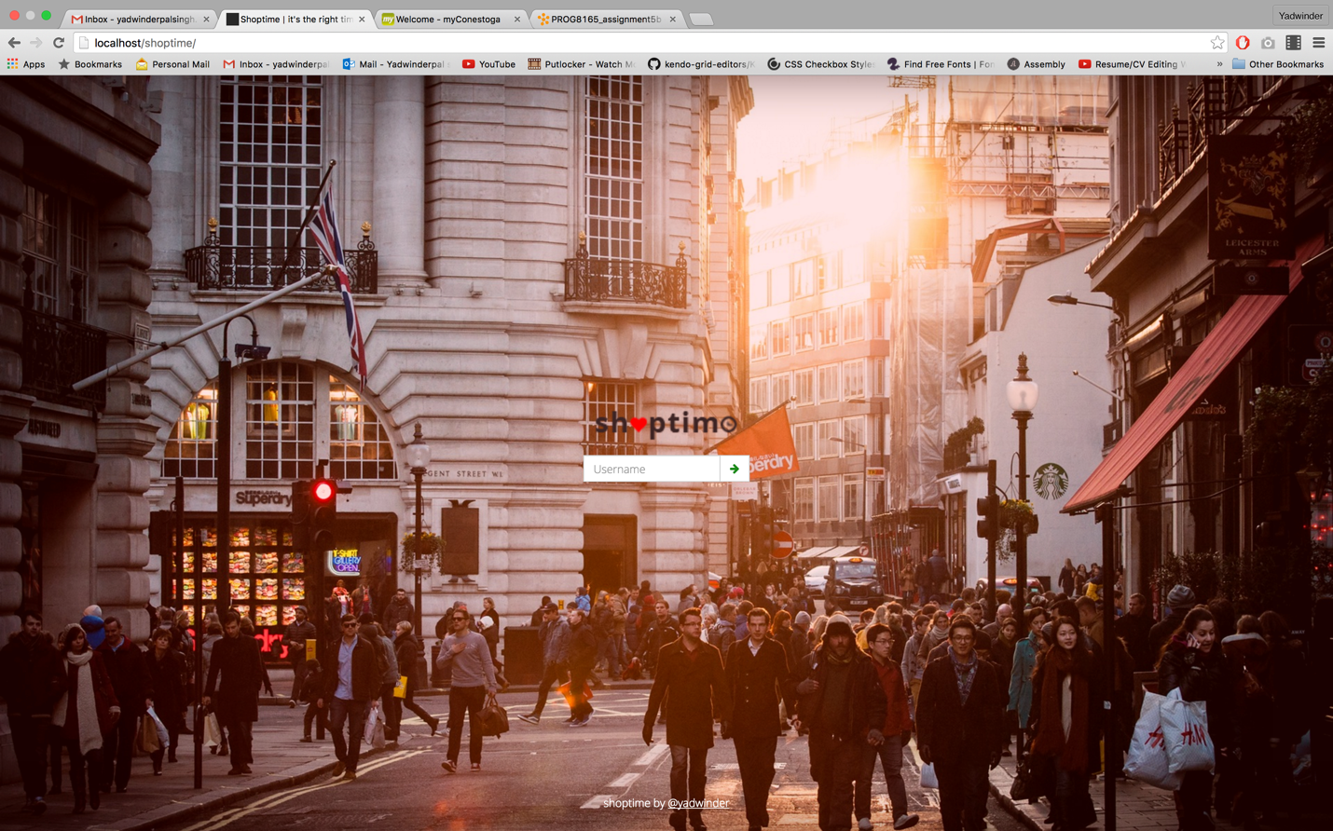

**Home after logging in successfully**



**Home after Sign out**



**Men Section**

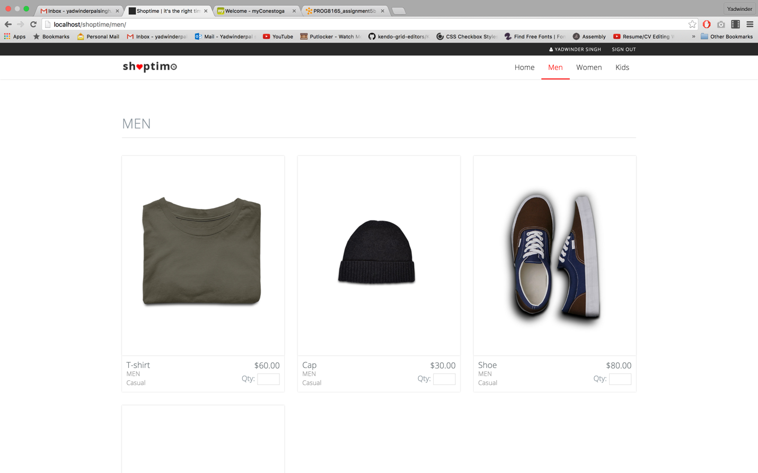

**Women Section**

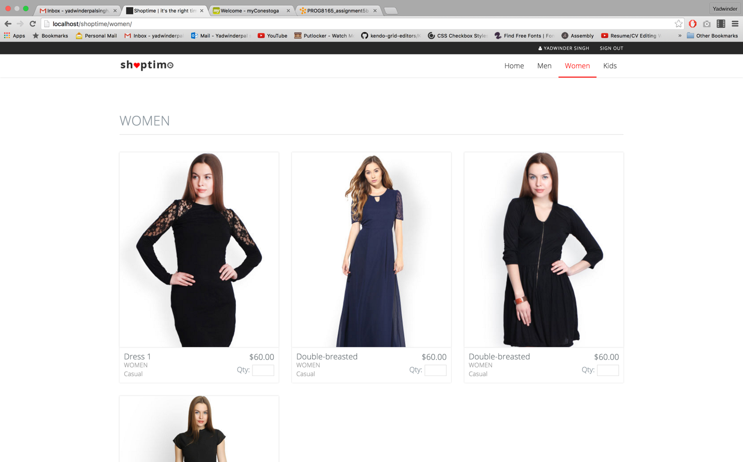

**Kids Section**

